**Data Acquisition System:**

A Data Acquisition System (DAS) is a set of components and tools designed to collect, measure, record, and analyze information from various sources. The primary goal of a data acquisition system is to convert real-world phenomena into digital data that can be processed and analyzed by computers.

Key components of a typical data acquisition system include:

**Sensors/Transducers**: These are devices that convert physical or electrical signals from the real world (such as temperature, pressure, voltage, etc.) into electrical signals that can be processed by the system.

**Signal Conditioning**: The raw signals from sensors often need to be modified or conditioned to make them suitable for processing. This may involve amplification, filtering, or other adjustments.

**Data Logger/DAQ Device**: This is the hardware component responsible for capturing and digitizing the conditioned signals. It typically includes an Analog-to-Digital Converter (ADC) to convert analog signals into digital form.

**Data Acquisition Software**: This software facilitates communication with the hardware, controls the data acquisition process, and allows users to configure and monitor the system. It may also include tools for data analysis and visualization.

**Computer/Controller**: The computer or controller serves as the central processing unit, managing the data acquisition hardware and software.

Data acquisition systems find applications in various fields, including industrial automation, scientific research, environmental monitoring, healthcare, and more. They are crucial for gathering accurate and timely data for analysis, control, and decision-making purposes.

**DAS for measurement of Potentiometer angular position:**

**Block diagram:**

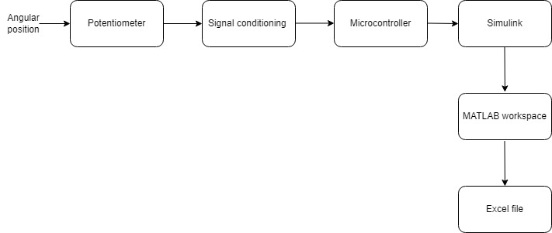

Figure 1: Block diagram of temperature DAS

* The potentiometer being used in this system is of value 10k and the angle of displacement ranges from 0 degrees to 270 degrees. The increasing order of angle is in the clockwise direction.
* The potentiometer is in voltage divider configuration, so output voltage and input voltage have nonlinear relationship.
* Signal conditioning is implemented to linearly map the change into the range of 0 to 5 Volts.
* The output of signal conditioning is provided to Arduino integrated with Simulink which maps voltage from 0 to 5 to angle 0 to 270 degrees.

**Signal Conditioning circuit**

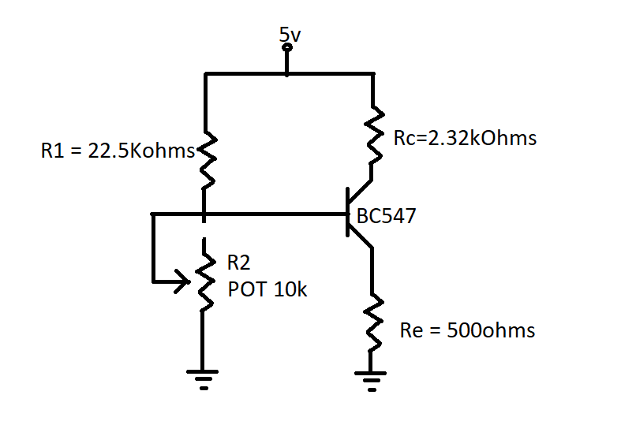

Figure 2: Connection of temperature sensor in voltage divider configuration

Steps for signal conditioning:

1. Choosing appropriate values of resistance R1 for voltage divider configuration:

We know that, for voltage divider configuration:

Vp=Vin

It can be seen that the relation between Vp and Vin for varying R2 is not linear. Therefore the output is not 0 to 5v at voltage divider point. The circuit is designed for Vout = 0.3v at 1.5v input and Vout = 4.9v at 0.4v input.

Calculation for fixed resistance R1:

At Vin = 5v, Rpot = 10k and Vp = 1.5v

10k/(R1+10k)=1.5/5

R1 = 23.33 kiloOhms

1. Varying collector resistance (Rc) and noting the nature of output voltage at collector for given input voltage at base, we can obtain following table for Rc = 2.32 kOhms

|  |  |
| --- | --- |
| Input(base voltage, Vb) | Output(collector voltage, Vc) |
| 0.5 | 5.01 |
| 0.68 | 4.61 |
| 0.87 | 3.76 |
| 1.05 | 2.88 |
| 1.24 | 1.91 |
| 1.45 | 0.98 |
| 1.52 | 0.3 |

By curve fitting, we obtain the following equation relating collector and base voltage:

Vc = -4.64Vb+7.63

The equation shows the linearity between collector and base voltage. In this way signal conditioning is obtained for 0 to 1.52v at the base to 0.3 to 5.01v at the collector. The equation was obtained for emitter resistance of 500 ohms.

**Simulink Implementation**

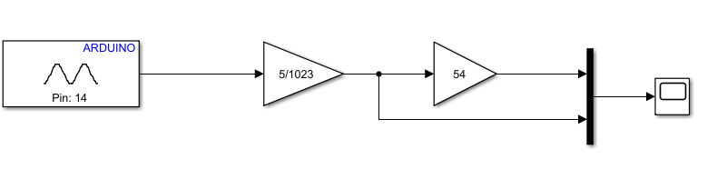

Figure 3: Recording temperature data using Arduino interfaced with Simulink

The collector terminal is connected to pin A0 of arduino for the measurement. The analog input is converted to corresponding 0 to 5v by using the gain block 5/1023. This value is converted to angular value by multiplying the voltage by 54.

At 5v, angle = 270 degrees

At 1v, angle = 54 degrees

Thus, degree = 54 * input voltage

The process begins with the acquisition of measured values. The measured value is exported to MATLAB workspace as an array. To pass as an array, an option inside scope page can be used. The data is stored as an array datatype and passed to the workspace. The workspace can be used to plot the data and store the data in an excel file.

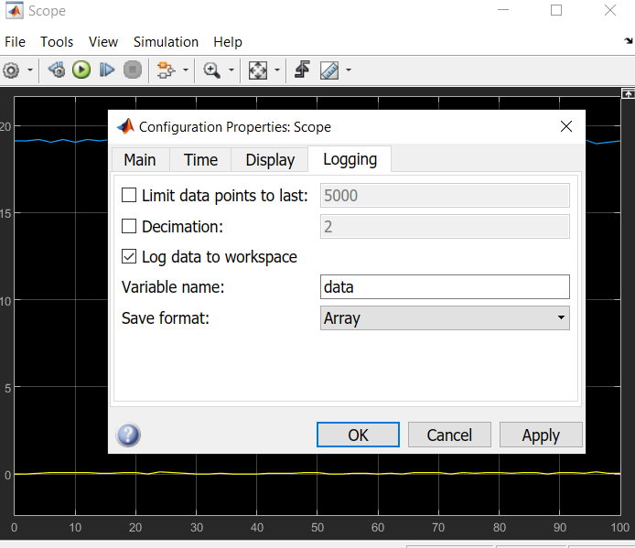

Figure 7: Passing the plot datapoints into MATLAB workspace as an array

To export the data into an excel file, following commands can be used in MATLAB command window.

clc

col_header = {'time','angle','voltage'};

xlswrite('logged_data',col_header,'Sheet1','A1');

xlswrite('logged_data',out.data,'Sheet1','A2');

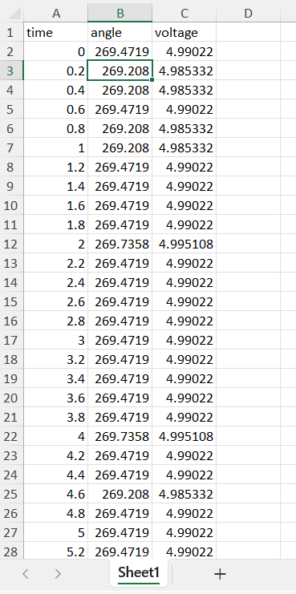

This will save the data with the name ‘logged_data.xls’ in destination in which command window is working.

Figure 8: Excel file generated by MATLAB function

For 461 seconds simulation, 2311 rows of data was generated. The plot of the data is shown below: 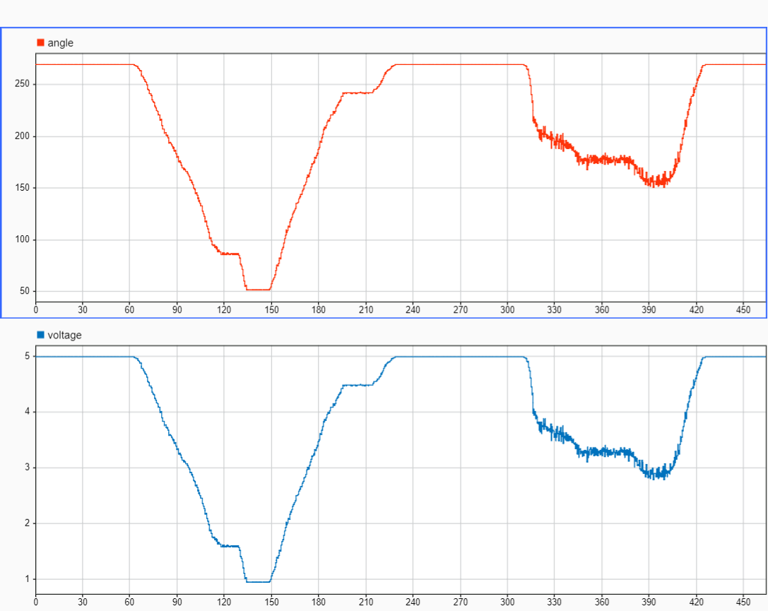

Figure 9: Plot of the recorded data points

The increase and decrease in the angular value is due to rotation of potentiometer knob. As time passes, the increase and decrease in voltage can also be seen. The minor variation fluctuation is due to disturbance and mechanical constraints of potentiometer.

**Hardware implementation:**

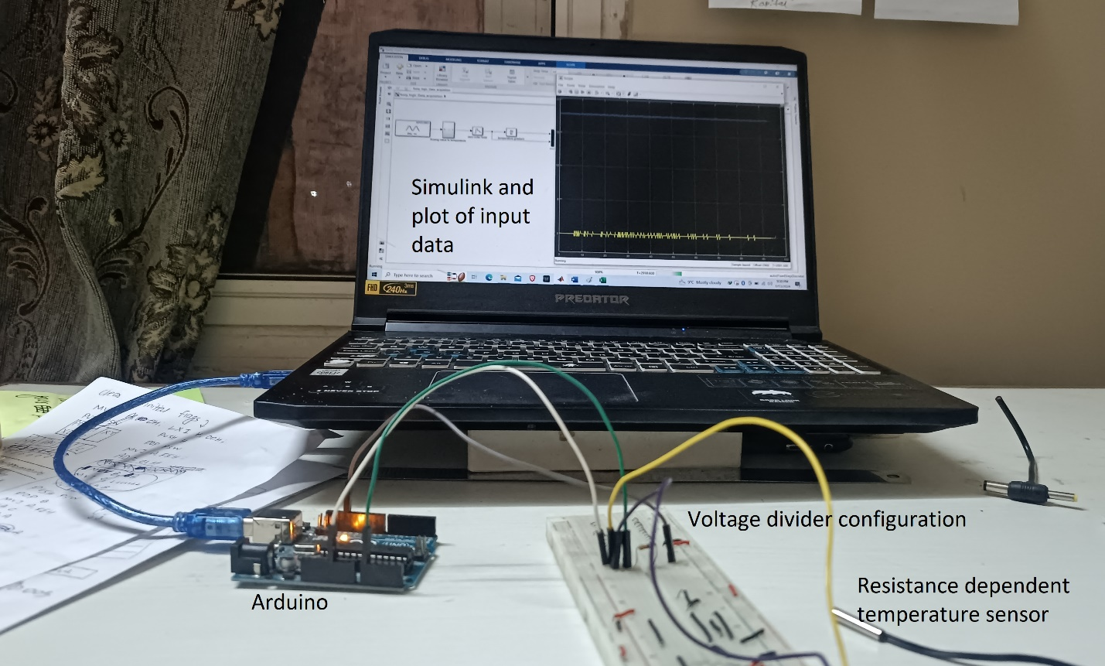

Figure 5: Hardware implementation of Data acquisition system